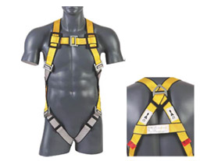

**UEE 273 FULL BODY HARNESS**

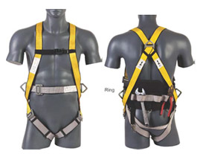

### UEE 285 FULL BODY HARNESS

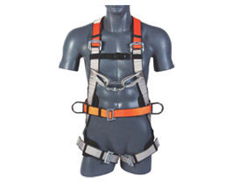

### UEE 296 TOWER HARNESS

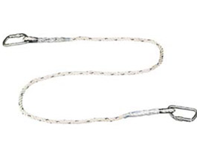

### LANYARDS

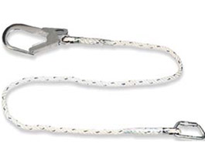

### LANYARDS

### C:\Documents and Settings\Administrator\Desktop\f.jpg

### LANYARDS

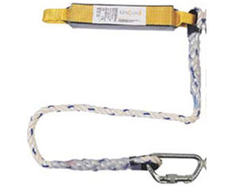

### KINETIC ENERGY ABSORERS

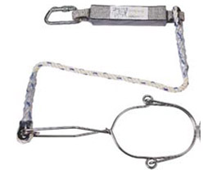

### KINETIC ENERGY ABSORERS

### C:\Documents and Settings\Administrator\Desktop\a.jpg

### KINETIC ENERGY ABSORERS

### C:\Documents and Settings\Administrator\Desktop\b.jpg

### KINETIC ENERGY ABSORERS

### C:\Documents and Settings\Administrator\Desktop\c.jpg

### KINETIC ENERGY ABSORERS

### C:\Documents and Settings\Administrator\Desktop\d.jpg

### FORKED TWIN LANYARD WITH KINETIC ENERGY ABSORBER

### C:\Documents and Settings\Administrator\Desktop\e.jpg

### SCAFFOLD HOOK

### C:\Documents and Settings\Administrator\Desktop\f.jpg

### KARABINER

### C:\Documents and Settings\Administrator\Desktop\g.jpg

### KARABINER

### C:\Documents and Settings\Administrator\Desktop\h.jpg

### KARABINER

### C:\Documents and Settings\Administrator\Desktop\i.jpg

### ANCHORAGE DEVICES

### C:\Documents and Settings\Administrator\Desktop\J.jpg

### ROPE GRABERS

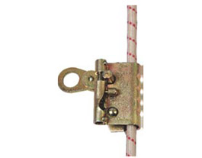

### ROPE GRABERS

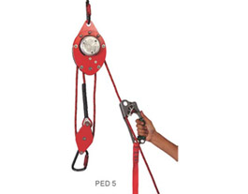

### ASCENDERS AND DESCENDERS

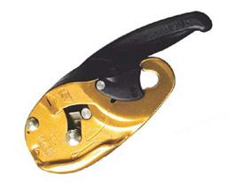

### ASCENDERS AND DESCENDERS